SIMATS ENGINEERING

ASSESSMENT TOOL 2

COURSE NAME: Database Management Systems COURSE CODE: CSA05

NAME:JAISURIYA D D

REG NO:192421167

COURSE OUTCOME COVERED

CO1: Analyze DBMS architecture, different data models, schema types, and design ER/EER diagrams, relational schemas for case-based scenarios by identifying entities and relationships. (BL1, BL2)

Activity Tool : Concept Mapping (Medium) Assessment Tool Weightage: 35%

Dr

QUESTIONS Total Marks: 50
Q.No | Question | Bloom's Level | Marks
1 | Construct a concept map linking the following terms: DBMS, Schema, Instance, Data Model, ER Diagram, Entity, Attribute, Relationship. | BL2 – Understand | 5
2 | Create a concept map for the three-level ANSI/SPARC architecture showing data independence at each level. | BL2 – Understand | 5
3 | Map the relationship between file-based systems and database systems, highlighting the problems solved by DBMS. | BL2 – Understand | 5
4 | Design a concept map for ER diagram components: entity, weak entity, attribute types, relationship types, and participation constraints. | BL2 – Understand | 5
5 | Construct a concept map comparing Hierarchical, Network, and Relational data models with their key properties. | BL2 – Understand | 5
6 | Develop a concept map for the EER model showing how it extends the basic ER model with generalization, specialization, and aggregation. | BL2 – Understand | 5
7 | Create a visual concept map for the DBMS software architecture, illustrating the flow from user request to data retrieval. | BL2 – Understand | 5

8 | Map the data models discussed in CO1 to real-world applications and explain the suitability of each model. | BL2 – Understand | 5
9 | Construct a concept map for schemas and instances, showing how they relate to physical and logical data independence. | BL2 – Understand | 5
10 | Design a concept map for the roles and responsibilities in a DBMS environment: DBA, End User, Application Developer. | BL1 – Remember | 5

Code of Conduct:

I JAISURIYA D D (192421167) certify that this submission is my original work and that I have adhered to the guidelines specified for this assessment. I understand that any violation of academic integrity rules will result in disciplinary action.

Signature of the student:

RUBRICS FOR CALCULATION:

Criteria | Weightage | Level 4 (Exemplary) | Level 3 (Proficient) | Level 2 (Developing) | Level 1 (Beginning)
Concept Identification | 25% | Identifies all key concepts from literature accurately and comprehensively | Identifies most key concepts with minor omissions | Identifies limited concepts; some are irrelevant or missing | Fails to identify essential  concepts
Linkages | 25% | Establishes clear, meaningful, and accurate relationships between concepts | Shows correct relationships with minor gaps | Relationships are weak, unclear, or partially incorrect | No meaningful relationships established
Organization | 20% | Concepts are well-structured hierarchically with logical flow and grouping | Mostly organized with minor structural issues | Some organization but lacks clear hierarchy | No logical organization or structure
Integration of Literature | 20% | Integrates multiple studies effectively to  show connections and comparisons | Shows some integration of literature | Limited integration; mostly isolated concepts | No integration of literature evidence

Clarity | 10% | Concept map is clear, neat, visually structured, and easy to interpret | Generally clear with minor readability issues | Clarity is reduced; difficult to interpret in parts | Poorly presented and hard to understand

1: Construct a concept map linking the following terms: DBMS, Schema, Instance, Data Model, ER Diagram, Entity, Attribute, Relationship.

Concept Map Flow:

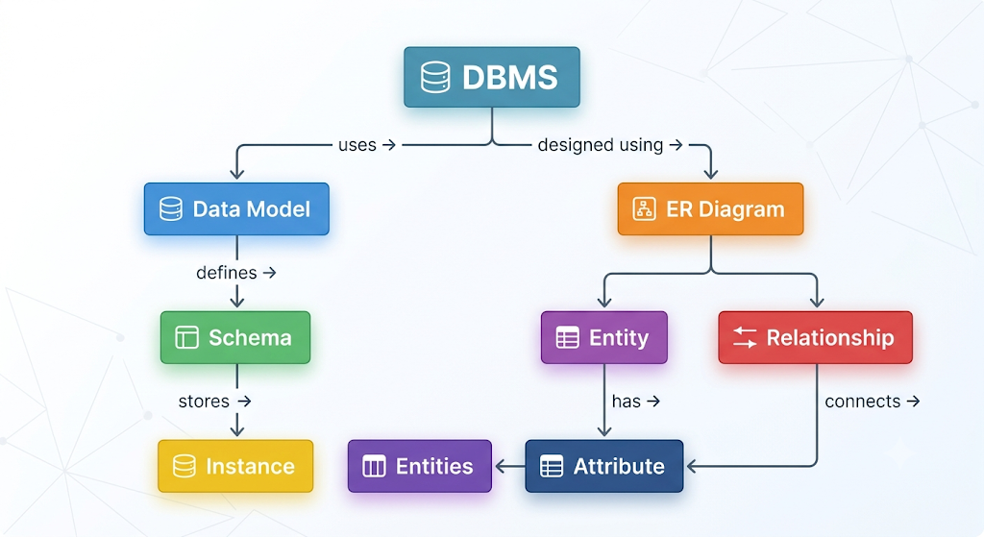

Question 2: Create a concept map for the three-level ANSI/SPARC architecture showing data independence at each level.
Concept Map Flow:
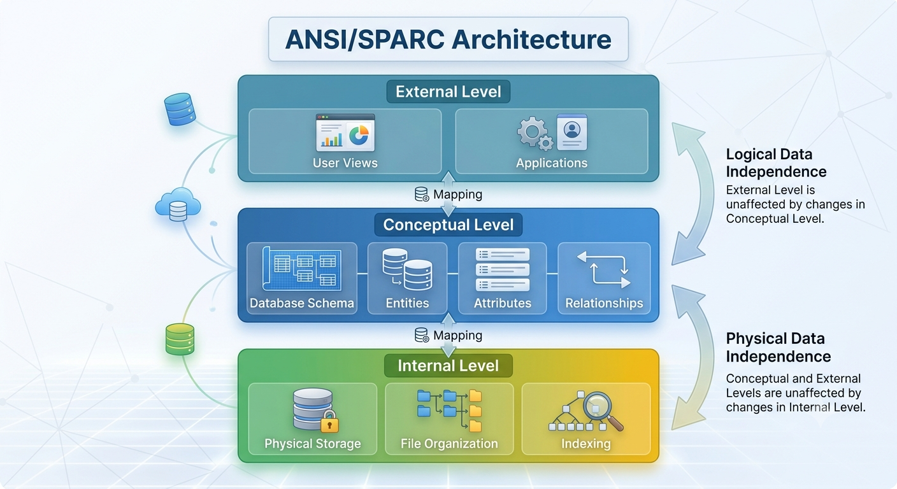
Question 3: Map the relationship between file-based systems and database systems, highlighting the problems solved by DBMS.
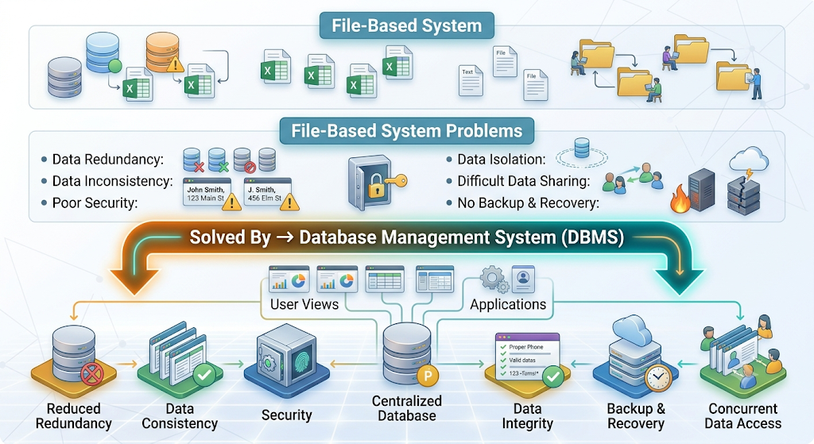

Question 4: Design a concept map for ER diagram components: entity, weak entity, attribute types, relationship types, and participation constraints.
Concept Map Flow
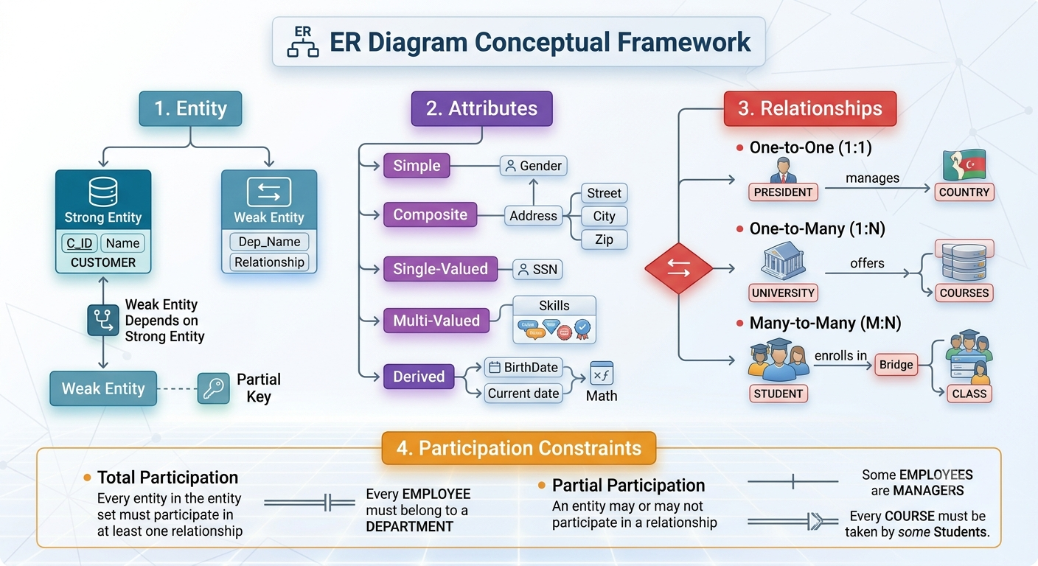

Question 5: Construct a concept map comparing Hierarchical, Network, and Relational data models with their key properties.
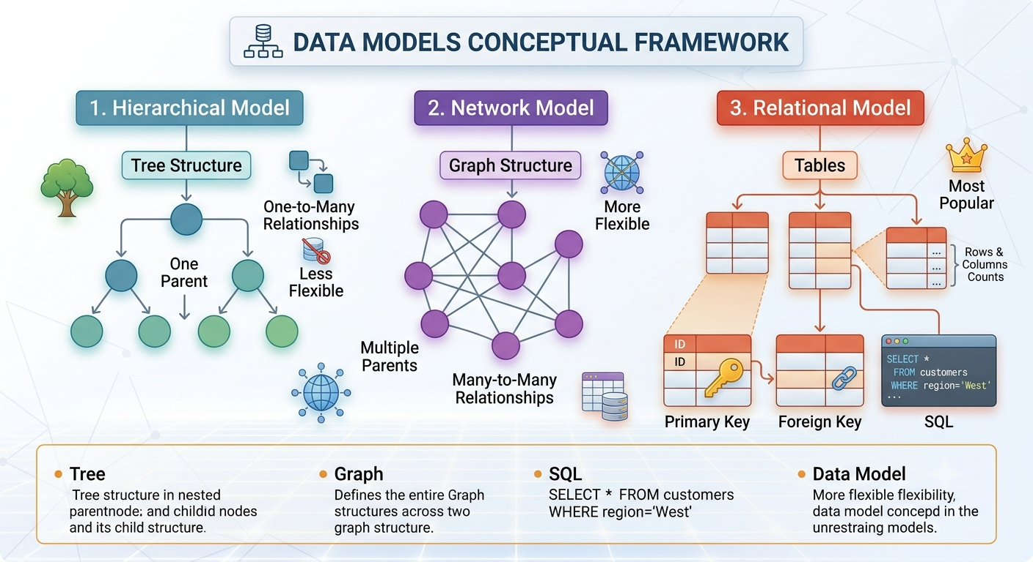
Question 6: Develop a concept map for the EER model showing how it extends the basic ER model with generalization, specialization, and aggregation.
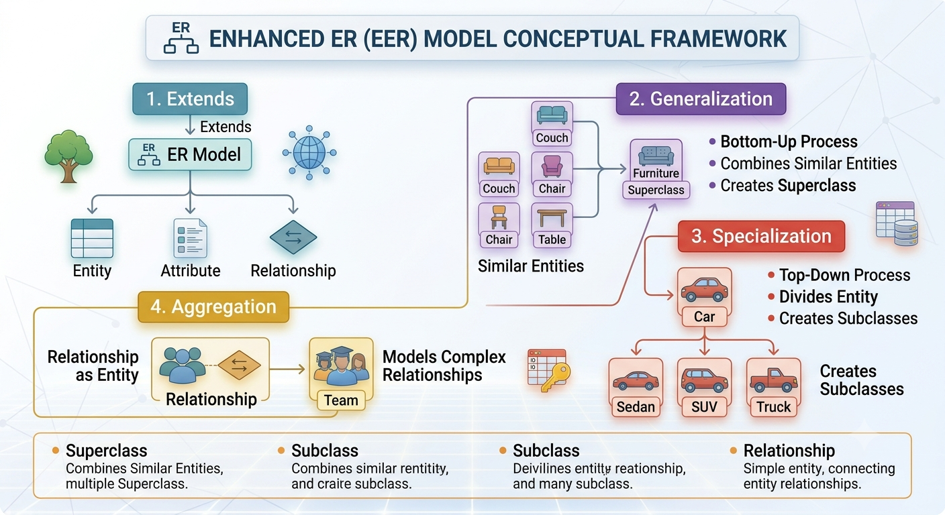

Question 7: Create a visual concept map for the DBMS software architecture, illustrating the flow from user request to data retrieval.

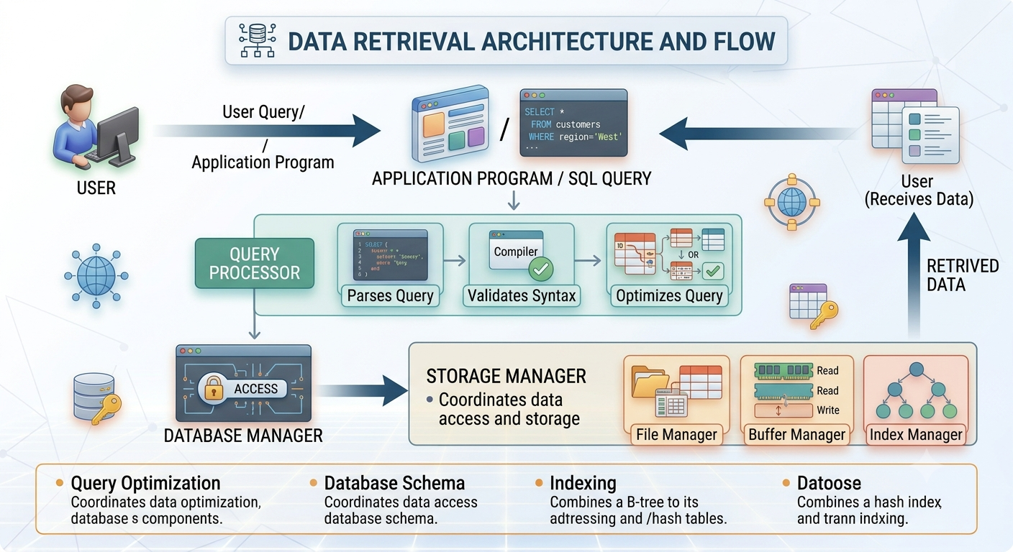
Question 8: Map the data models discussed in CO1 to real-world applications and explain the suitability of each model.
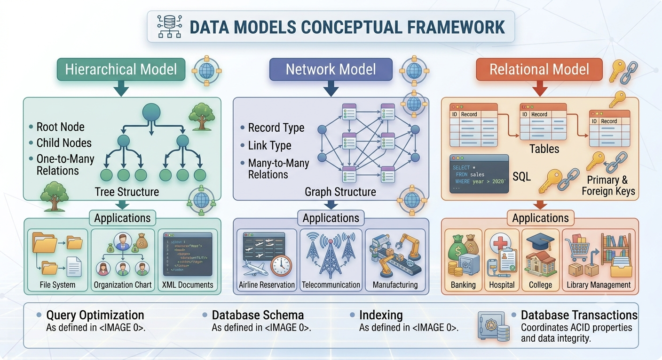

Question 9: Construct a concept map for schemas and instances, showing how they relate to physical and logical data independence.
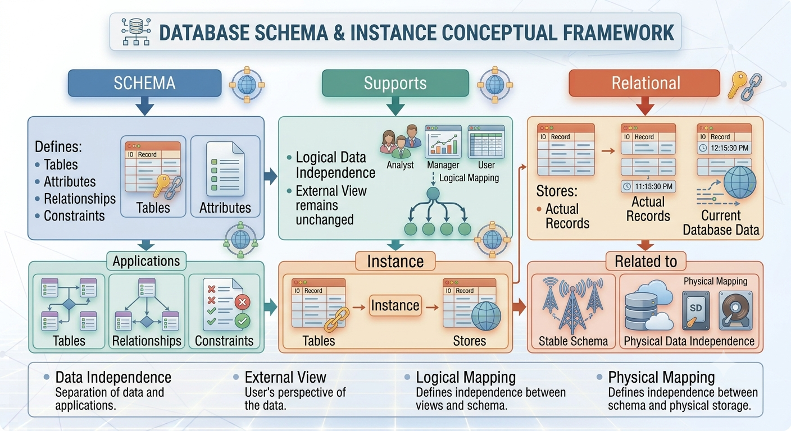
Question 10: Design a concept map for the roles and responsibilities in a DBMS environment: DBA, End User, Application Developer.
